## System interfaces

The main page of the system is illustrated in Figure 6.3 that contains at the above of the page a moving bar containing the daily trips. Also, a fixed menu is there with a login button. At the center, there is a slideshow contains information about the system and its values.

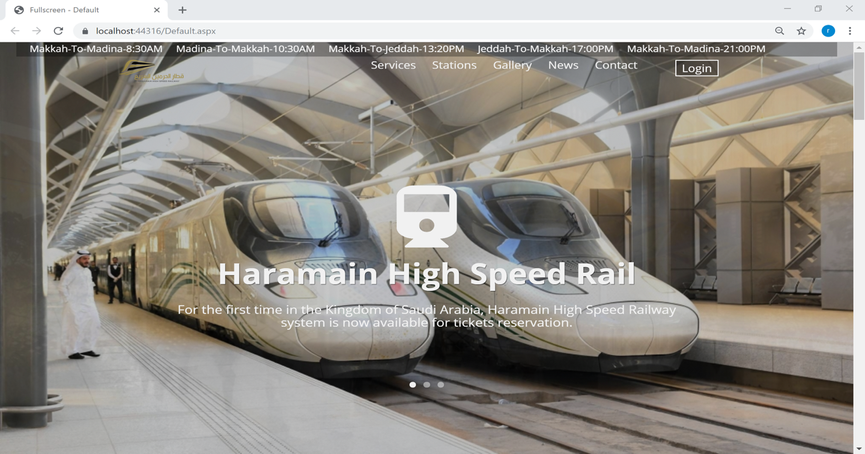

Figure 1.1 The main page of the system

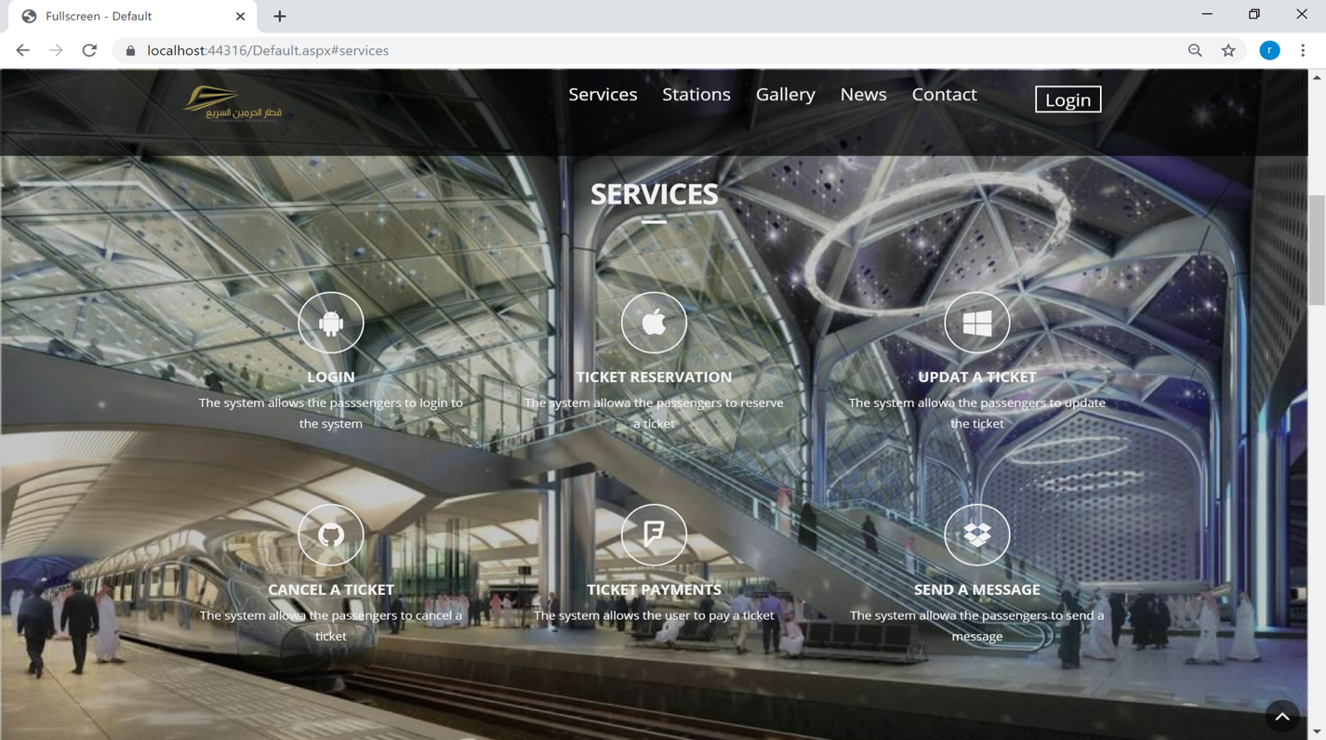Figure 6.4 shows that the system gives a user an option to know more about the system by showing them the services of the system.

Figure 1.2 Services of the System

Haramain Train stops at 5 stations which are Makkah, Madina, Jeddah, KAEC, and KAIA. Figure 6.5 shows that the system introduces the stations to the users.

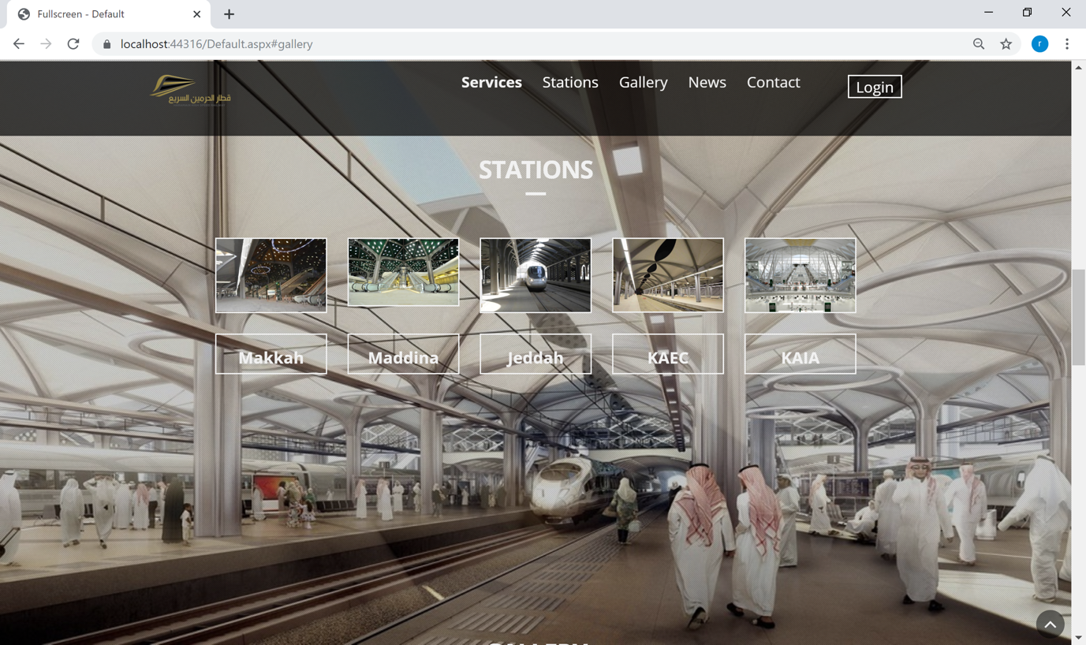

Figure 1.3 Stations of the Trains

Figure 6.6 shows that the system shows the user some gallery of the stations with a choice to filter them by choosing a station name to display its images.

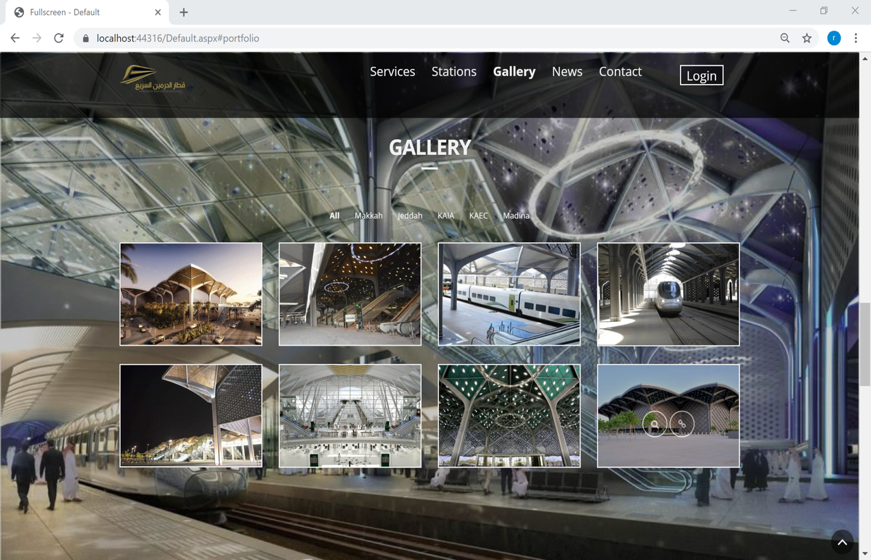

Figure 1.4 Gallery of the stations

Figure 6.7 shows that the system displays news to the users about the Haramain Railway.

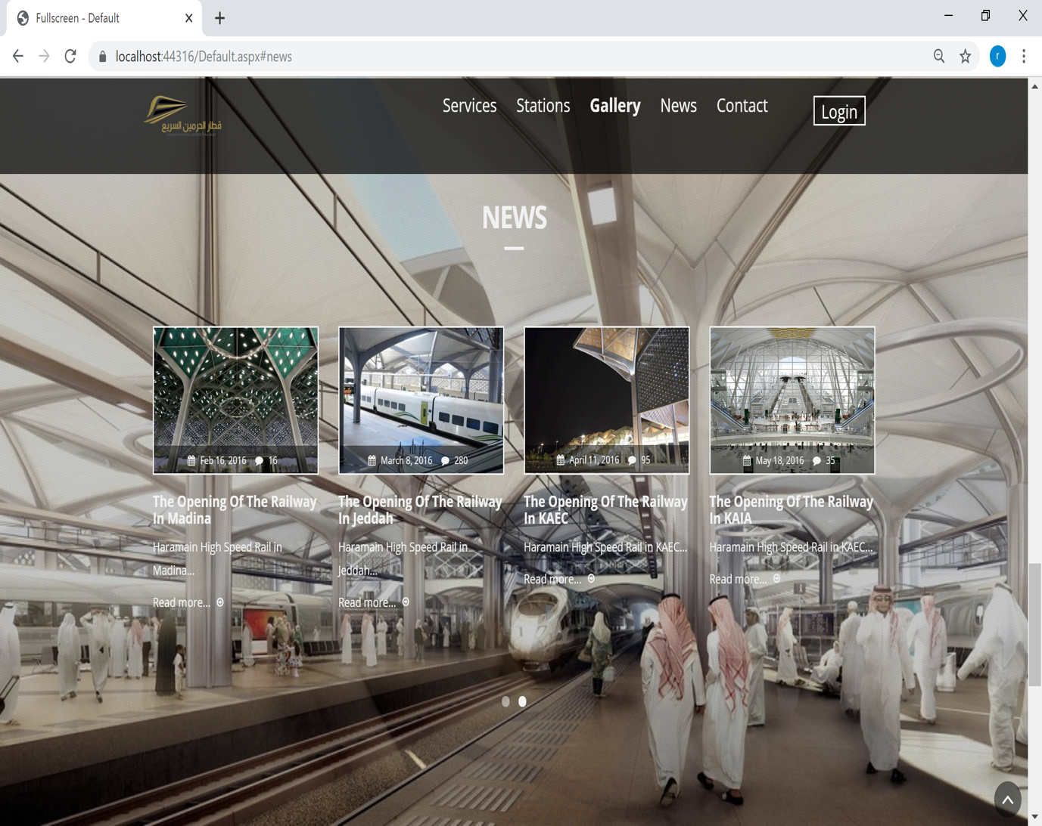

Figure 1.5 News of the Haramain Railway

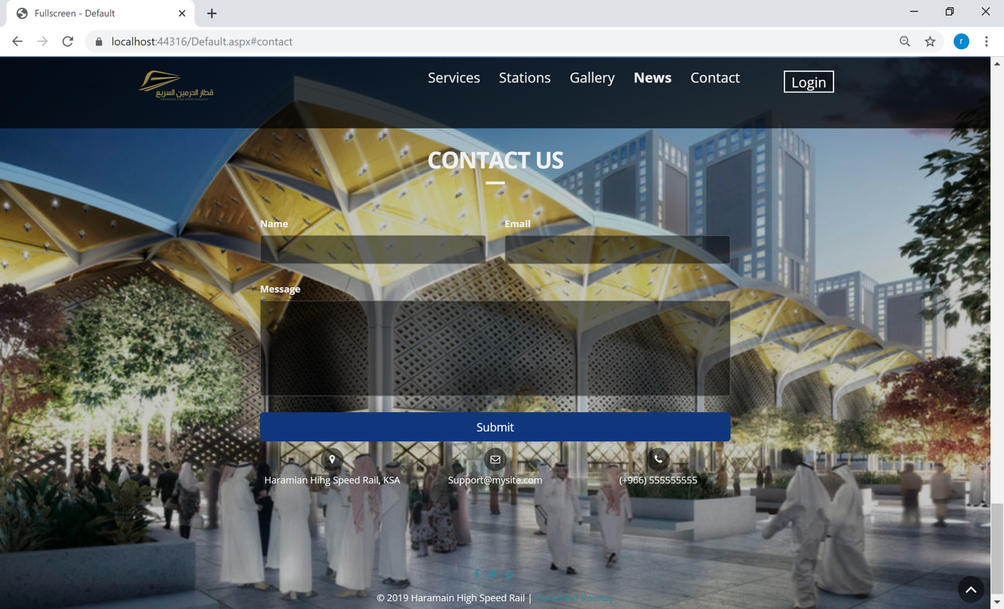Figure 6.8 shows that the system allows the users to send a message.

Figure 1.6 Send a Message

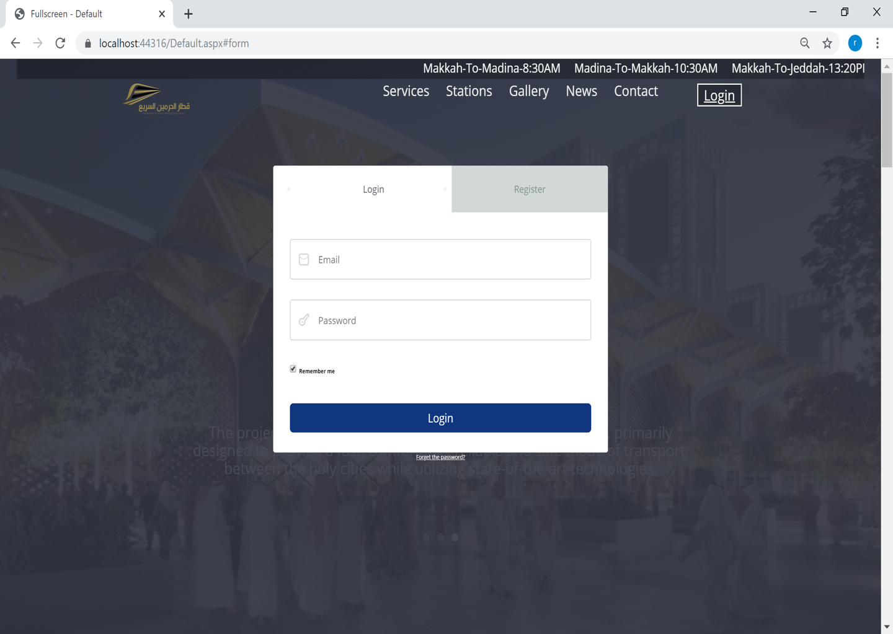Figure 6.9 shows that the user can login to the system.

Figure 1.7 Login to the System

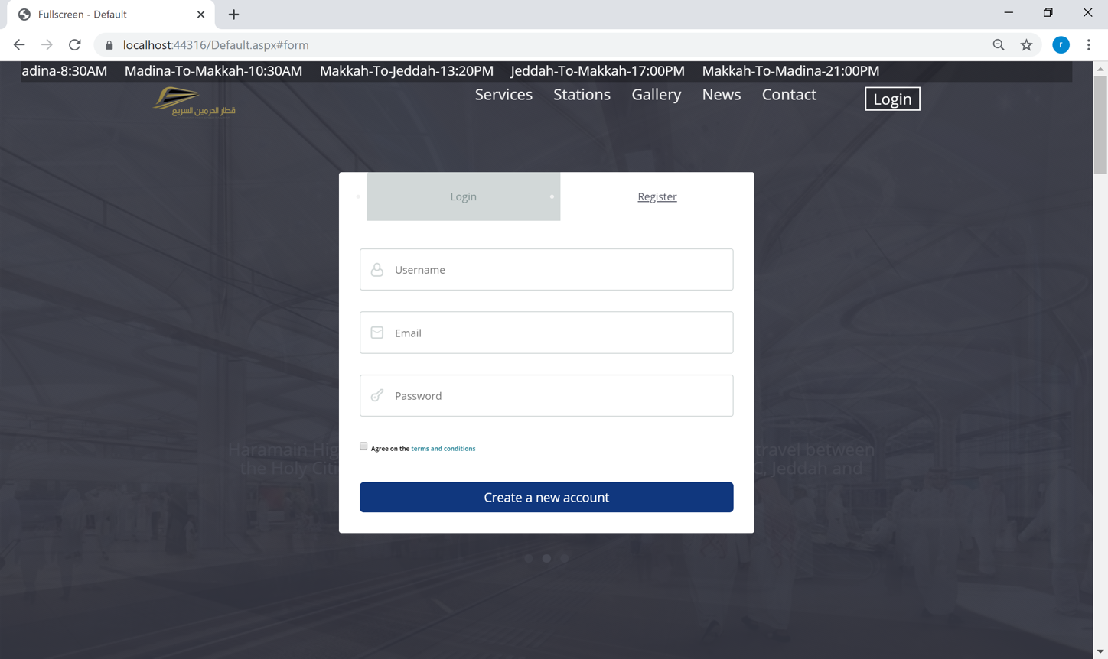Figure 6.10 shows that the user can register to the system.

Figure 1.8 Register to the System

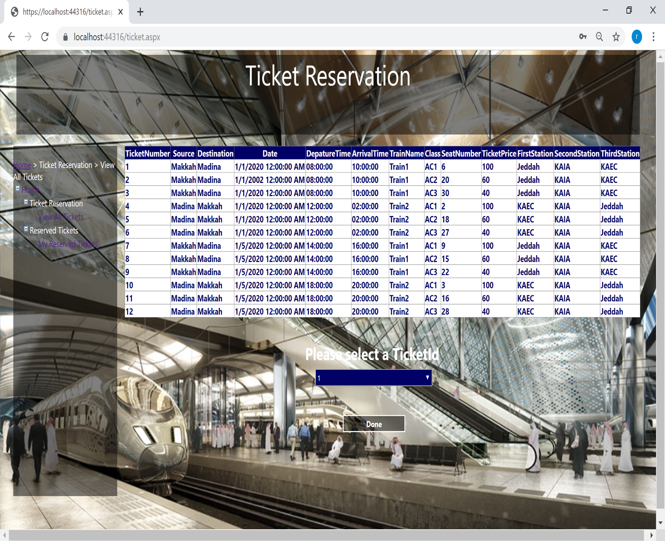Figure 6.11 shows that the system displays all the available tickets to the users and gives the user a choice to choose the required ticket to be reserved by adding a dropdown list, and there is a sitemap contains the available tickets page and reserved tickets page.

Figure 1.9 Display all the Available Tickets

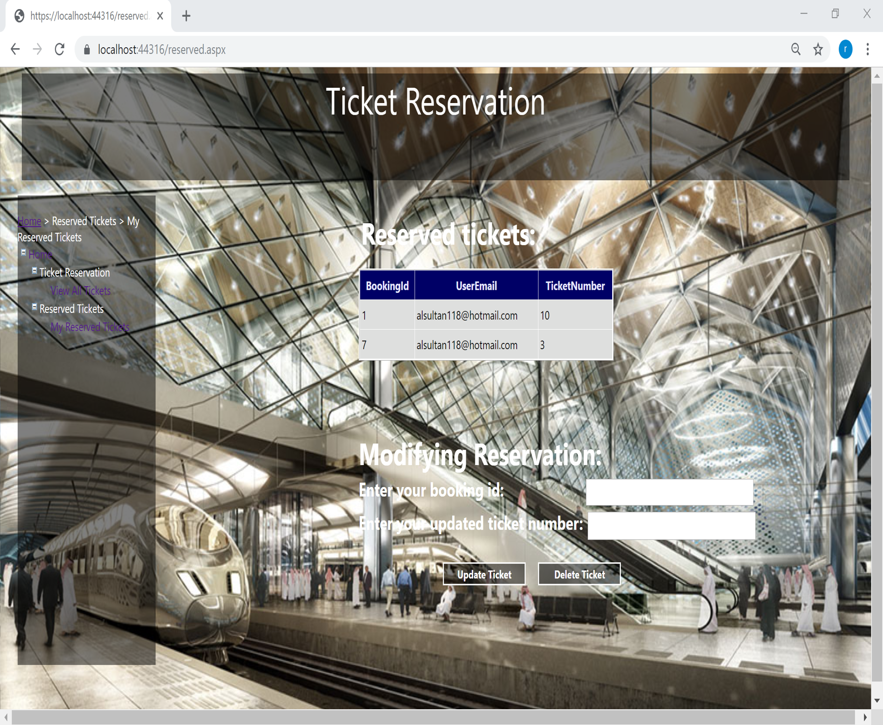Figure 6.12 shows all the reserved tickets by a user. In addition, there is an option to modify the tickets either update the ticket or delete the ticket.

Figure 1.10 Display the Reserved Tickets